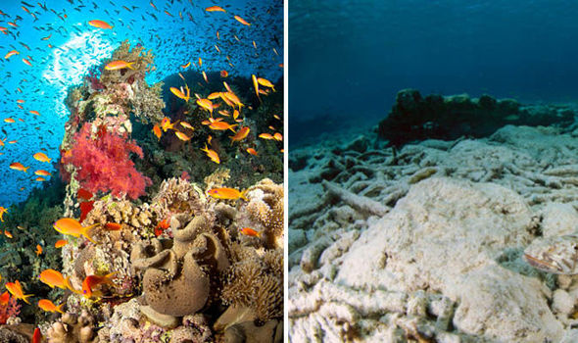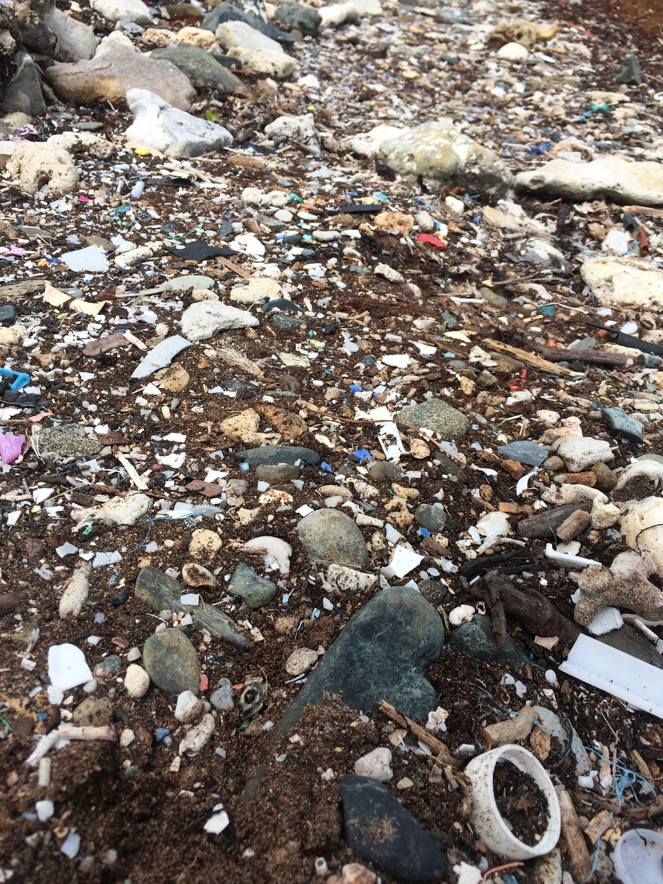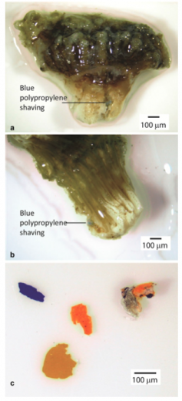 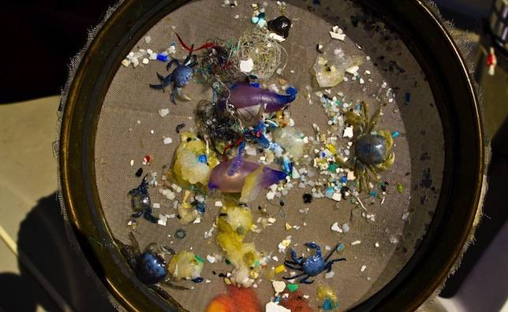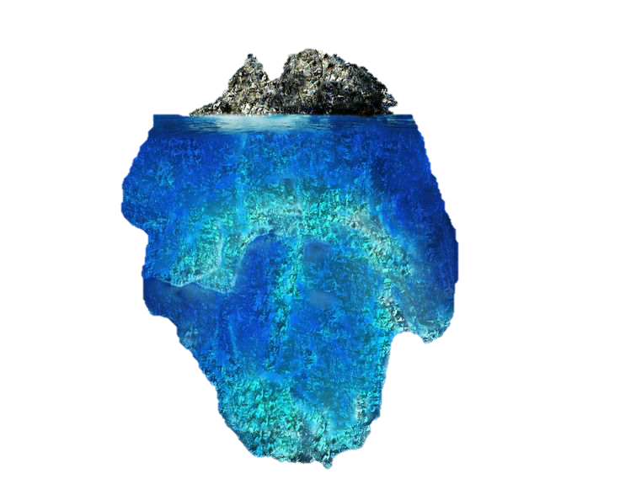

Photo by Madeline Denton

http://www.express.co.uk/news/nature/613593/sunscreen-coral-reefs-environment-pollution-oxybenzone

Hall, N. M., Berry, K. L., Rintoul, L., & Hoogenboom, M. O. (2015). Microplastic ingestion by scleractinian corals. *Marine Biology Mar Biol,* *162*(3), 725-732. doi:10.1007/s00227-015-2619-7

Endocrine Disrupting & Other Chemicals

Chemicals can leach from the plastics and have a detrimental impact on corals and the other vital organisms that make up coral reefs. These include plastic additives and other chemicals that can adhere to the hydrophobic polymer. This can have a variety of effects on the reef, such as encouraging algal growth, harming the endocrine system of various organisms, and lowering reproductive success. Understanding the effects on corals still requires further investigation.

Microplastics are any synthetic polymer particle that is less than 5 millimeters in size. They can either be primary, which are plastics that are intentionally produced to be microscopic, or secondary, which is a microplastic that comes from a larger piece of plastic that has degraded. Areas with varying topography, such as reefs, allows for the buildup of microplastics. They can easily travel long distances in water due to their inherent properties, such as their light weight, durability, and buoyancy.

## Microplastics

Microplastics and Corals

coraldigest.org

Drew Hoag and Maddi Denton

http://www.mnn.com/lifestyle/recycling/blogs/new-6-year-study-reveals-the-secret-life-of-ocean-plastic

# The Great Pacific Garbage Patch

https://www.pinterest.com/pin/447897125413335591/

**Also known as “Trash Island”, the Great Pacific Garbage Patch is an area approximately the size of the state of Texas that is a dense and massive swirling accumulation of trash, much of which is plastic. It is a vortex of trash and debris in the North Pacific, which is almost entirely caused by humans. It is bounded by an ocean current known as the North Pacific Subtropical Gyre, and is largely a connection of millions of tiny fragments of plastic. As these plastics break down they become more and more dangerous to marine life. Because approximately 70% of Marine debris sinks to the ocean floor, it is very possible that the sea floor in and around this and other gyre-bound garbage patches is even more polluted than the soupy trash matrix above it.**

**Also known as Integer eu nunc.** Suspendisse nonummy mauris eu justo. Nunc vehicula dui a quam. Aenean rutrum. Cras varius purus sed quam. Vivamus nisi ligula, lobortis nec, venenatis id, molestie nec, diam. Etiam condimentum ultrices libero. Duis consectetuer ligula ut velit tincidunt molestie. Duis libero sem, convallis eget, luctus ac, volutpat vel, nulla. Mauris vulputate neque et nulla. Nullam vulputate volutpat turpis.

##### Microplastic consumption by corals is now being seen as a major threat. Recent studies have revealed that corals polyps are non-selective feeders, and discriminate food only by size. Microplastics continue to accumulate in ocean waters and around coral reefs, increasing consumption by corals. The microplastics become lodged deep in the stomachs of corals, impeding digestion and potentially being fatal to the polyps. A 2015 study conducted by the ARC Centre of Excellence in Coral Reef Studies revealed that corals do in fact mistake plastic of equivalent size as food. Indigestible microplastics fill the tiny gut-cavities of the corals, inhibiting them from regular feeding.

What can you do?

##### Microplasticslargely come from the deterioration of larger plastics. It is important for everyone to take steps to reduce marine litter that contributes to the collection of these plastics. From small steps like investing in a reusable water bottle and avoiding products with excess packaging to contributing to marine conservation and clean up organizations, everyone can help to make a huge difference in the quality of our oceans.

##### 

Morbi scelerisque, quam in pellentesque auctor, massa erat nonummy erat, vitae pulvinar quam arcu eu libero. Proin quis arcu aliquet ante nonummy feugiat. Curabitur id dolor in diam posuere commodo. In metus nulla, commodo ac, fringilla et, suscipit id, erat. Proin cursus magna vehicula felis. Donec dolor leo, ornare vehicula, gravida sed, condimentum iaculis, ligula. Nullam sollicitudin adipiscing quam. Donec sapien est, scelerisque in, imperdiet et, porttitor ut, sapien. Duis sit amet sem. Nam in enim cursus mi cursus egestas.

### Plastic Consumption